Saint Bridget Parish Council Minutes  
**Wednesday; May 21, 2025**

|  |  |
| --- | --- |
| Father Ken Shuping PRESENT  Rev. Seth Seaman PRESENT  Bruce Slough, Chairperson PRESENT  Allie Strollo, Secretary PRESENT  Pat Accardo PRESENT  Julia Williams PRESENT  Mike Wilder PRESENT | Frank Devenoge ABSENT  Tom Giannasi ABSENT  Kristine Keeney ABSENT  Mack Rich PRESENT  John Rogers ABSENT  Tara Chiudian PRESENT |

# Opening

* 6:01 PM – Meeting was called to order by Bruce Slough
* Opening prayer, Father Ken

# Approval of Minutes

* 6:03 PM Meeting minutes from April 2025 meeting minutes were approved by the council

# Liaison Reports

## Liturgy – Mack Rich

* Acknowledgment of notable liturgies for June Sundays
  + June 1st - Ascension of our Lord
  + June 8th - Pentecost
  + June 15th - Holy Trinity
  + June 22nd - Corpus Christi

## Christian Formation-Kristine Keeney

* Below is the information about this year's First Holy Communion Class
  + 70 second and third grade children received their First Communion in May.
  + Another 4 older elementary and middle school and high school students receive their First Communion on June 8th
  + 55 surveys were returned
    - The responses from the survey were mixed regarding the textbooks used (Blessed, First Reconciliation and First Communion), with many parents commenting on the number and length of lessons, keeping up with the reading schedule and the difficulty keeping their child engaged.
    - Many parents used the supplemental videos and they were considered informative and entertaining.
    - Many parents questioned why sacramental prep wasn’t being taught in the school and in the Sunday religious education program and felt it was not a priority for the church.
    - The First Reconciliation and First Communion retreats were praised for their content and for Fr. Ken’s talks but some felt there was a lag between the Retreat and when the sacrament was received.
  + Looking Ahead to Next Year
    - curriculum changed to Pflaum’s Together in Jesus series (First Reconciliation and First Eucharist). The content is easily taught at home and there are 6 lessons in each book. Detailed teaching instructions will be sent home with each book, as well as a family guide and Mass Book to help each student follow along and understand the Mass.
    - There are a variety of supplement online resources, including videos.
    - There will be a parent meeting on September 14th where it will be stressed that sacramental preparation is not stand alone, but that children need to either be enrolled in a Catholic school or participate in the church’s Sunday Religious Education program.
    - We will also review the Diocesan guidelines for Sacramental Preparation which explains why sacramental preparation should be done at home.
    - The retreat dates and celebration of the sacraments have been changed to be closer to each other.
    - First Reconciliation retreats will be held January 10th and 24th with the sacrament being offered on February 7th and 14th.
    - First Communion retreats will be held April 18th and 25th with First Communion Masses being celebrated May 2/3 and May 9/10.

## Social Ministry- Julia Williams

* We have also received 28 calls for assistance thus far, and have helped 3 and worked or referred with other partners to help those we could not due to location or the request not in the scope of our program.
* Early in the month, we kicked off our Spotlight Ministry for Mary’s Choice RVA. We included information about the ministry and a baby bottle campaign that will run through the month of May.
* We also assisted our Communities in Schools partner Blackwell Elementary with their teacher appreciation event by gathering cookies and treats for a teacher cookie bar on May 5 th . We received a gracious thank you note from the CIS Coordinator at Blackwell and have posted it in the commons.
* Both our feeding ministries had events in the second week and have also gained some additional new members to help.
* Parish members who participate with Rotary Club held a bike collection at the middle school this past weekend. The total bike haul was more than 150 bikes (they are thinking around 170). They were hoping for 100 so this far exceeded expectations.
* Saint Vincent DePaul held their first ever spaghetti dinner event on May 17th . They hosted just under 200 attendees and raised over $2400.00. This can help 4 more friends over the course of the summer.
* Walking with Moms held their first ever Mother’s Day Tea event on Sunday May 18th . We hosted 8 moms and children and a Case Manager from East End Pregnancy Center. Volunteers from Saint Bridget and Saint Michael’s Walking with Moms supported the event and provided the tea service, nursery, and as table hosts. A volunteer/student photographer was also present to take family photos that will be shared with the mothers.
* The Haiti ministry shared an updated this past month from Fr. Pierre regarding a possible 200 additional refugees from Port au Prince that are receiving support at the school/mission in Carrisade.
* There will be a zoom meeting on May 21st to get additional information/updates. Jo Ellen shared the latest information with the parish ahead of the second collection on June 7/8.
* June Activities
* WWM will be touring East End Pregnancy Center
* CCC will be having a 5K event and picnic open to all parishes
* Housing Families First is also having a 25th Anniversary Celebration we have been invited to join.
* June’s Spotlight ministry will be St. Francis Manchester, and they also will have an

activity to share with our parish. More information will be available soon about that event.

We are also working to schedule the events/logistics for 2025-20206 and taking time in June to get additional planning underway for the fall and winter.

# Pastor Report

## Fr Ken

* October 10-11 Catholic Fest at the Diamond
* Two seminarians joining this summer

# Principal Report

* Congratulations to Colleen Blazsak who was celebrated at this year’s Excellence in Catholic Education Award for Saint Bridget
* Last week was Teacher Appreciation Week
* Celebrations coming up: Senior Walk, New Family Events, 8th Grade Graduation, Field Day
* Meghan Hess will be the Interim Principal moving forward

# Old Business

* **Nursery**
  + Ratio requirements, square footage of space, and age play factors in re-opening the nursery as a staffed position
  + Concerns have been raised about noise level during mass (specifically with children, etc)
* **Locked ladies room**
* **Disciple Maker Index Survey**

# 

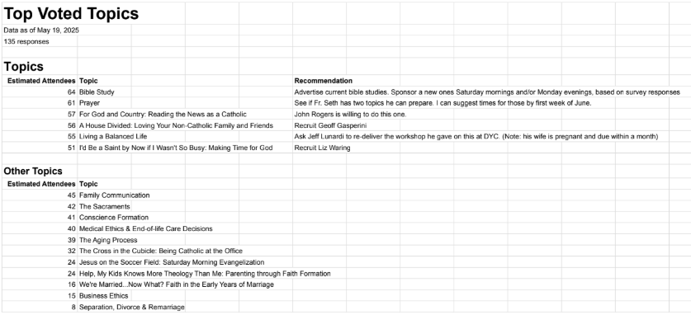

# New Business

* New Parish Council Members
  + 3 candidates/3 positions
  + Elections May 31-June 1
* June 25 possible Parish Council/Finance dinner

# Parishioner Feedback/Suggestion Box

* Stripping of the alter
* Review of usher protocols
* Redoing Mary
* Communication concerns about dates/times
  + Reminder of Flock Notes during daily mass

# Adjournment

* Meeting adjourned 7:29 PM